TxtFileInfo

A Java command line program to get information about words in a text file.

Prerequisites:

* Java SE Development kit 15.0.2
* Set Java Path (e.g. set path=C:\Program Files\Java\jdk-15.0.2\bin)
* Command prompt or Terminal

Installation:

I have compiled this as a runnable Jar file. So it does not need to be installed; rather Java SE Development kit 15.0.2 needs to be installed and have the path set to use the “Java” command in cmd. I have uploaded the project with all the code from my Eclipse IDE to this repository too but chose a runnable jar file to prevent any JDK compatibility problems as it is running one of the latest releases.

Assumptions:

This program looks through a text file to give information about the words in that file. As to what defines a word, here are the assumptions:

* Numbers like “1” are defined as a word with the length of 1, “23” defined as a word with the length of 2 and so on.
* Dates like numbers are counted as one word. 17/02/2021 would be considered a length 10. Because of the numbers and the “/” which I have not left out per the example given on the challenge blurb.
* Any of the following blue punctation characters (, . ; : " * ? ! ') are not considered in the length of words. If the removal of these characters takes a word length to zero for example (*****) would return 0, are not counted by program.
* Any punctation characters that are not defined in the above increment a words length. But, because it is a Regex command, it can be altered easily to fit a different assumption of a word.

How to use:

Assuming JDK SE Development kit 15.0.02 has been installed and the Java path set. As it is a command line program, you need to be in same directory to run it. Once in the same directory you can run the program with the following command with 1 argument that is the file location (the Program will not take no or multiple arguments. If no or multiple arguments are passed, it will fail and exit out).

*java -jar TxtFileInfo.java file_location_argument*

Step by Step guide to using the program:

* Move the file “TxtFileInfo.java” onto your system.
* Open the cmd or terminal and move to the folder storing the program:

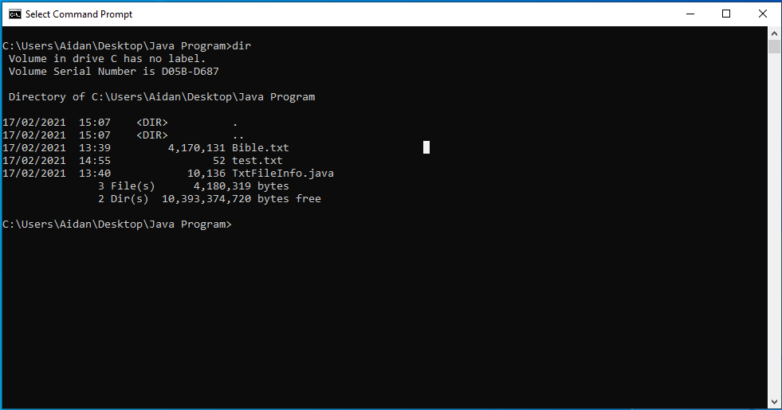

* 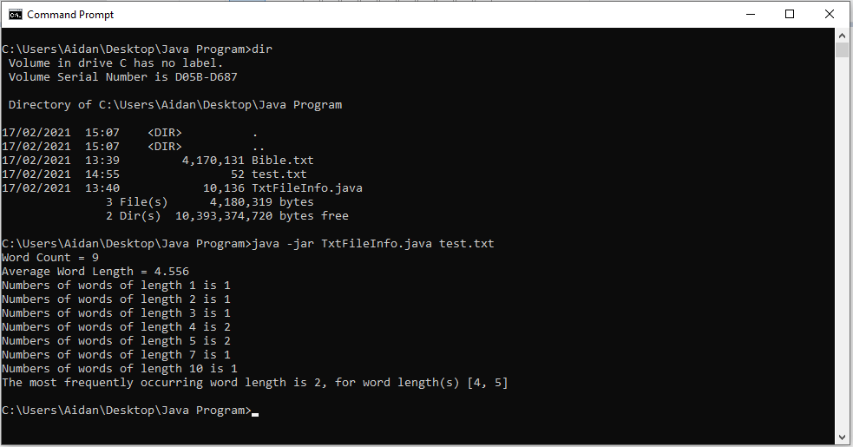After you are in the same folder of the program, you can run the java command above. Below shows it against a text file with the data “Hello world & good morning. The date is 18/05/2016.”:
* The Program can also read text files in different folders, below shows the program reading Bible.txt, which is a txt file of the bible from <http://janelwashere.com/files/bible_daily.txt>:

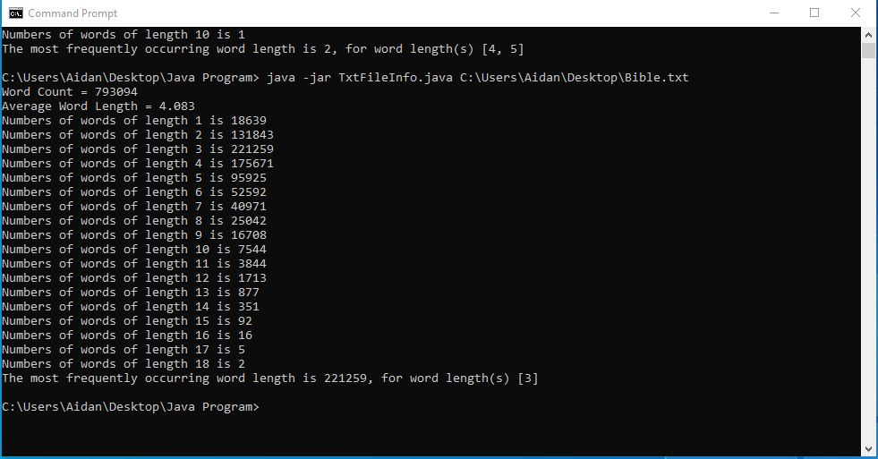

* After reading the file the program exits itself.